END OF YEAR AWARDS
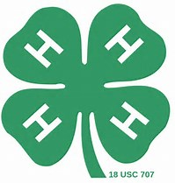

The Gold Star Award is the highest county achievement award and will be awarded only once in a member’s 4-H career. The 4-H member must have completed projects in three different project areas, have submitted appropriate record forms, and have participated in one or more activities in at least three of the following areas: Educational Presentations, Citizenship activities, Projects, Project exhibits, Camps, Leadership labs or Public relations.
Gold Star History
“The presentation of the Gold Star Pin was begun in 1933. Records tell us that presenting the pins was prompted by an effort to recognize the people who did the work rather than the agents.
Previous to this time, the agents submitting the largest number of 4-H records received the recognition.
In the beginning each county made a nomination of their outstanding 4-H member and 100 members were selected to receive the award. After several years, the awards were presented to the outstanding 4-H boy and 4-H girl in each county.”
In 1985, the Gold Star begin to be awarded to the top 4-H members in a county, regardless of gender.

The Silver Star Award is presented to intermediate 4-Hers who have excelled in the area of 4-H involvement, personal growth, leadership, and community service.
The Bronze Star Award is presented to junior 4-Hers who have excelled in the area of 4-H involvement, personal growth, leadership, and community service.
The Rookie of the year is presented to first year 4-Her who have excelled in the area of 4-H involvement, personal growth, leadership, and community service.

